AI Assignment 3:

TASK-1:
● Ask AI to write a function to calculate compound interest, starting with only the
function name. Then add a docstring, then input-output example
Expected Output#1
● Comparison of AI-generated code styles

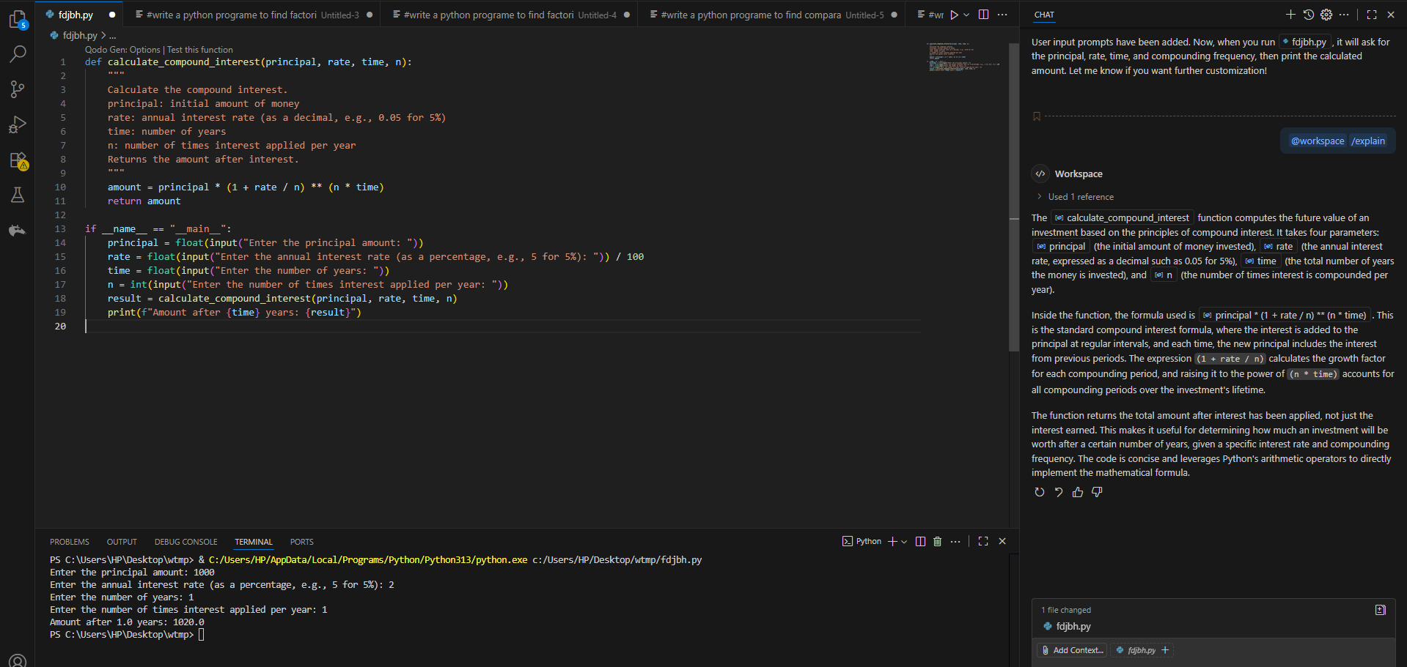

TASK-2:
● Do math stuff, then refine it to: # Write a function to calculate average, median, and
mode of a list of numbers.

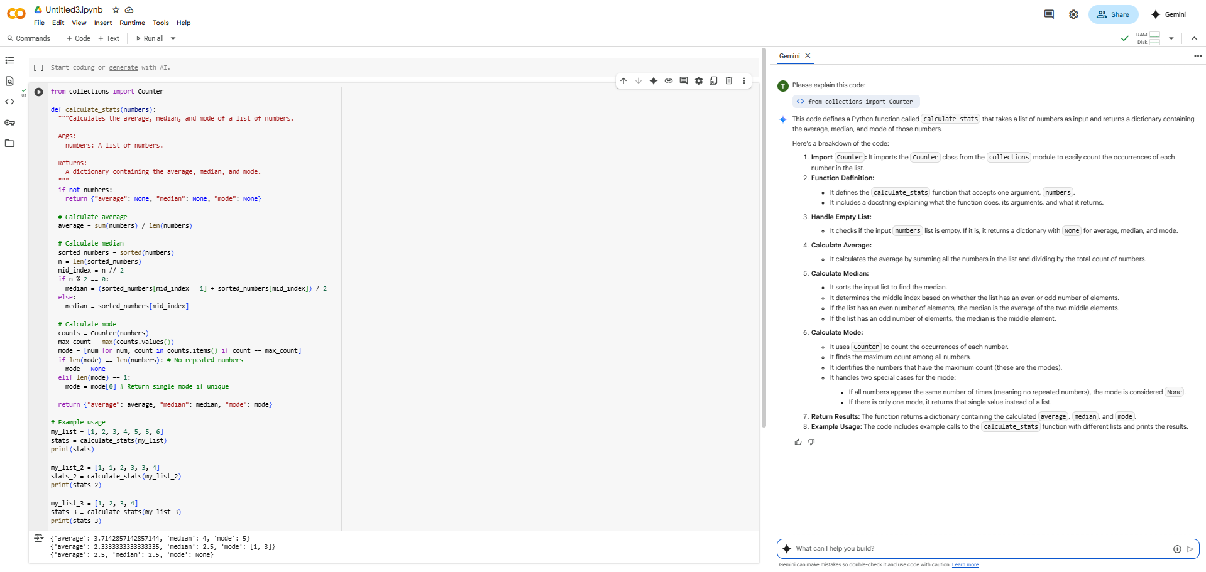

TASK-3:
● Provide multiple examples of input-output to the AI for convert_to_binary(num)
function. Observe how AI uses few-shot prompting to generalize.

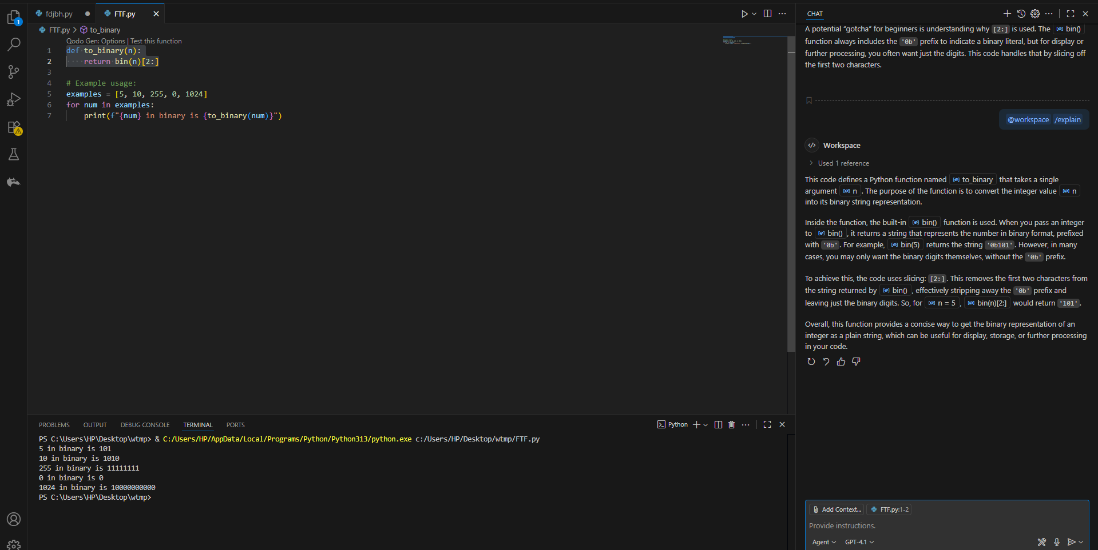

TASK-4:
● Create an user interface for an hotel to generate bill based on customer requirements

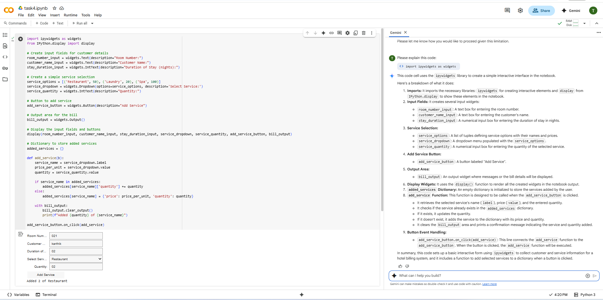

TASK-5:
● Analyzing Prompt Specificity: Improving Temperature Conversion Function with
Clear Instructions

